GARIMA UPPAL LAB SHEET 09 CU240251618 SEB=B 22

!pip install ultralytics
# Install Ultralytics
!pip install -q ultralytics # Import libraries
import cv2
import numpy as np
import matplotlib.pyplot as plt import os
from ultralytics import YOLO
print("All libraries imported successfully!")

Creating new Ultralytics Settings v0.0.8 file
View Ultralytics Settings with 'yolo settings' or at '/root/.config/Ultralytics/settings.json'
Update Settings with 'yolo settings key=value', i.e. 'yolo settings runs_dir=path/to/dir'. For help see https://docs.ultral
All libraries imported successfully!
# 1. LOAD PRE-TRAINED YOLOv8 MODEL
# ============================================================

print("\nLoading YOLOv8 model...") model = YOLO("yolov8n.pt")
print("YOLOv8 model loaded successfully!")
Loading YOLOv8 model...
Downloading https://github.com/ultralytics/assets/releases/download/v8.4.0/yolov8n.pt to 'yolov8n.pt': 100% ━━━━━━━━━━━━ 6. YOLOv8 model loaded successfully!
# 2. UPLOAD IMAGE
from google.colab import files uploaded = files.upload()
if len(uploaded) == 0:
print("ERROR: No image was uploaded.") else:
# Get the actual uploaded file name file_name = list(uploaded.keys())[0] image_path = "/content/" + file_name

print("\nImage uploaded successfully!")
print("Image Path:", "/content/pexels-friededia-30649280.jpg")

Choose Files pexels-fried…649280.jpg
pexels-friededia-30649280.jpg(image/jpeg) - 5622111 bytes, last modified: 8/13/2026 - 100% done
Saving pexels-friededia-30649280.jpg to pexels-friededia-30649280 (1).jpg

Image uploaded successfully!
Image Path: /content/pexels-friededia-30649280.jpg
# 3. LOAD IMAGE
image = cv2.imread("/content/pexels-friededia-30649280.jpg") if image is None:
print("ERROR: Image could not be loaded.") else:
print("\nImage loaded successfully!") print("Image Size:", image.shape)
Image loaded successfully!
Image Size: (5464, 8192, 3)
# 4. IMAGE PREPROCESSING

import cv2

# Convert BGR image to RGB
image_rgb = cv2.cvtColor(image, cv2.COLOR_BGR2RGB)

# Resize image to 640 x 640
processed_image = cv2.resize(image_rgb, (640, 640))

print("Image preprocessing completed.") print("Image Size:", processed_image.shape) print("PRIYANSHUN SHARMA CU240250980")

Image preprocessing completed. Image Size: (640, 640, 3) PRIYANSHUN SHARMA CU240250980
%pip install -q ultralytics
# 5. PERFORM OBJECT DETECTION
# ============================================================

print("\nDetecting objects...") print("PRIYANSHUN SHARMA CU240250980")

results = model(image_path) print("Object detection completed.")
Detecting objects...
PRIYANSHUN SHARMA CU240250980

image 1/1 /content/pexels-friededia-30649280 (1).jpg: 448x640 (no detections), 437.0ms
Speed: 16.5ms preprocess, 437.0ms inference, 16.8ms postprocess per image at shape (1, 3, 448, 640) Object detection completed.
# 6. GET DETECTION RESULT
result = results[0]
# Create image with bounding boxes detected_image = result.plot()
# Convert BGR to RGB for Matplotlib detected_image_rgb = cv2.cvtColor(
detected_image,
cv2.COLOR_BGR2RGB
)
# 7. PRINT DETECTION RESULTS
print("\n============================================================") print("DETECTED OBJECTS") print("============================================================") print("PRIYANSHUN SHARMA CU240250980")

object_count = 0

for box in result.boxes: object_count += 1
# Class ID
class_id = int(box.cls[0])

# Object name
class_name = model.names[class_id]

# Confidence score
confidence = float(box.conf[0])

# Bounding box coordinates
x1, y1, x2, y2 = box.xyxy[0].tolist()

print("\nObject", object_count)
print("Class
:", class_name)
print("Confidence :", round(confidence, 2))

print(
"Bounding Box:",
"(",
round(x1, 2),
",",
round(y1, 2),
",",
round(x2, 2),
",",

round(y2, 2),
")"
)
============================================================
DETECTED OBJECTS
============================================================ PRIYANSHUN SHARMA CU240250980

============================================================ TOTAL OBJECTS DETECTED: 0
============================================================
PRIYANSHUN SHARMA CU240250980
# 8. TOTAL OBJECTS print("\n============================================================")
print("TOTAL OBJECTS DETECTED:", object_count) print("============================================================") print("PRIYANSHUN SHARMA CU240250980")
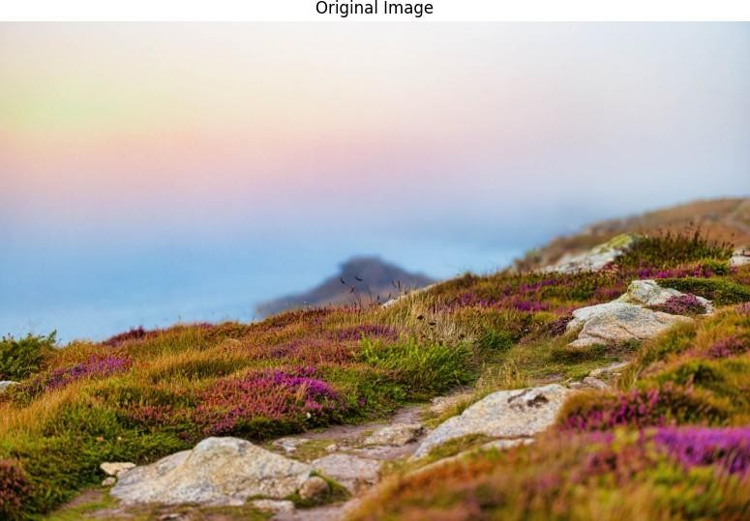
# 9. DISPLAY ORIGINAL IMAGE
plt.figure(figsize=(10, 7)) plt.imshow(image_rgb) plt.title("Original Image") plt.axis("off")
plt.show()
# 10. DISPLAY DETECTION RESULT
plt.figure(figsize=(10, 7)) plt.imshow(detected_image_rgb) plt.title("YOLOv8 Object Detection Result") plt.axis("off")
plt.show()

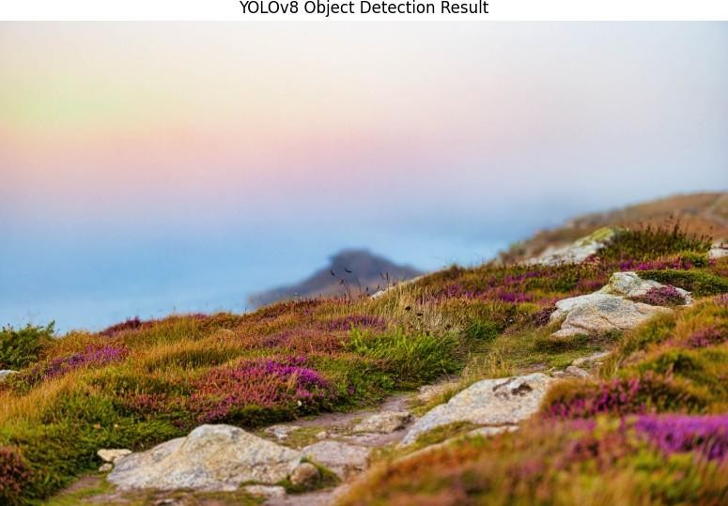

# 11. SAVE DETECTION RESULT
output_path = r"D:\machine learning\computer vision\detected_result.jpg"
cv2.imwrite(
output_path, detected_image
)
print("\nDetection result saved successfully.") print("Saved at:", output_path) print("PRIYANSHUN SHARMA CU240250980")

Detection result saved successfully.
Saved at: D:\machine learning\computer vision\detected_result.jpg PRIYANSHUN SHARMA CU240250980

============================================================ EVALUATION
============================================================
Number of detected objects: 0

The detected objects are displayed with:
- Bounding boxes
- Class labels
- Confidence scores PRIYANSHUN SHARMA CU240250980
Experiment completed successfully.
# 12. EVALUATION
# ============================================================ print("\n============================================================") print("EVALUATION") print("============================================================")
print("Number of detected objects:", object_count) print("\nThe detected objects are displayed with:") print("1. Bounding boxes")
print("2. Class labels") print("3. Confidence scores")
print("PRIYANSHUN SHARMA CU240250980")
print("\nExperiment completed successfully.")

